TOBACCO ROOT GEOLOGICAL SOCIETY 42nd ANNUAL FIELD CONFERENCE
LEADORE, IDAHO, JULY 27-30, 2017

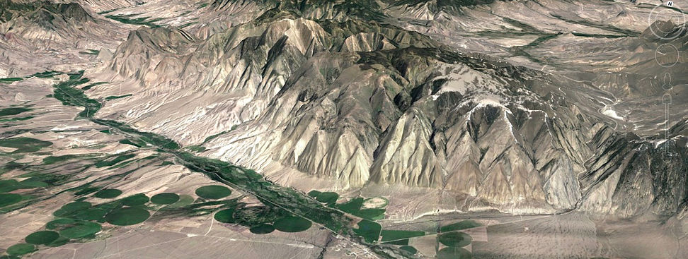

CALL FOR FIELD TRIP LOGS, PAPERS AND CONFERENCE VOLUNTEERS

TRGS will hold its 42nd Annual Field Conference in Leadore, Idaho July 27-30, 2017. Leadore is located along the Lemhi River between the Beaverhead Mountains and the Lemhi Range in central Idaho. The region is known for its mineral resources and complex geologic history including rocks of the Belt Supergroup, Paleozoic limestones, anomalous Ordovician intrusives, Fold-Thrust structures, Challis volcanics, and Basin & Range extension. We welcome field trips or papers on any aspect of the geology of the field conference area of east-central Idaho and southwest Montana. The guides and papers will be published in Northwest Geology, the annual publication of TRGS. Please contact Bruce Cox (bcox737@gmail.com) by April 1, 2017 with the titles of proposed field trips or papers. Contributors, please visit https://www.trgs.org/northwest-geology to review the submission guidelines. All manuscripts and road logs must be received by May 1, 2017. If you would like to help with conference duties, please contact Emily Geraghty Ward (emily.ward@rocky.edu).

Meeting Location
Our venue will be the Leadore Community Center and Library (http://leadore.lili.org/) in downtown Leadore. Leadore is located 46 miles south of Salmon, Idaho. There are two hotels and RV park in town and abundant camping opportunities in the nearby Salmon-Challis National Forest.
Schedule and Logistics
The meeting format is informal and includes Friday morning invited talks, half-day field trips on Friday afternoon, and all day field trips on Saturday, Sunday, and possibly Monday. There will be an informal poster session on Friday evening. Catered meals will be available for purchase. Details of field trip schedules and instructions on pre-meeting registration will be available on the TRGS website at www.trgs.org by early June. For further information, contact Bruce Cox (bcox737@gmail.com)

